Name: Marcelino Sutanto | Title: Understanding the Story of Humanity’s Population Shift

- Objectives
The objective of this project is to give an understanding of how the world population has shifted over time and how it is projected to be in the coming years. This project will also briefly touch on how the population of each continent changed over time and which ones will lead the newer generations. The main message of the presentation is that change has already occurred and although it may feel alarming at first, it is more about what we can do to support this new change rather than what we should do to prevent it.

- Novelty
The animated bar race chart is one of the new visualization techniques that I implemented which is based on the plotly framework. The animation shows the top 10 countries with the biggest population which changes dynamically as we progress over the years (Figure 4). Instead of showing static snapshots or images, this helps show the process of change and we can watch how these countries shift in and out of the top 10, which is also great as we do not have to show all the countries at once and just show the relevant ones.
Another technique that I used is the dual axis charts which combines two charts of different range values into one. This is good for comparing two charts side by side in the same scale, as putting them in different scales can disperse the concentration of the audience and can be quite small if we were to place them in the same slide in the presentation. I used this to show the population paradox: population in numerical values and population growth rate in % which shows two opposite trend line which may seem counterintuitive (Figure 1).
For the population change by region (Figure 3), I decided to use a slope chart instead of a regular line chart. Although the line chart will show more details, I wanted to emphasize on the overall growth between the continents for the historical data (1950 to 2023) and the projected data (2024 to 2100) and the slope chart seems to be more intuitive and clearer with no noise rather than the typical line chart.

- Technical Challenges and Innovation
All the visualizations were created using python in Jupyter notebook (source to be added) and I used the libraries: pandas, matplotlib, seaborn and plotly.
Pandas was used mainly for loading, handling and cleaning the dataset as well as manipulating the data frames like creating, dropping and renaming columns.
Matplotlib was used for plotting most of the graphs which includes the dual axis plots for population size vs growth rate (Figure 1), age structure pie chart (Figure 2), population change by continent slope chart (Figure 3) and the 2x2 subplot for the conclusion (Figure 7).
Seaborn was used for the plotting of the bubble chart for fertility vs median age (Figure 5) and the heatmap of correlation between fertility rate, life expectancy, median age and growth rate (Figure 6)
Plotly was used only for the bar race chart (Figure 4) as it requires animation.
The technically challenging aspects were mostly in the bar race chart (mentioned above in novelty) as it was the first time I did it. Updating the range of x and the frames and transition is quite difficult as the animation looks very clunky at first and requires a lot of tuning. The dual-axis chart also created a visual distortion at first and requires matplotlib’s twinx() to create independent y-axis for the 2 different categories.

- References
[1] Main dataset used: Compact version of the UN World Population Prospects 2024 dataset (https://population.un.org/wpp/)
[2] Dataset used in Figure 2: Our World in Data’s “Population of young, working-age and elderly” dataset (https://ourworldindata.org/grapher/population-young-working-elderly)

Figures and Tables
In the order of the visualizations in the presentation:
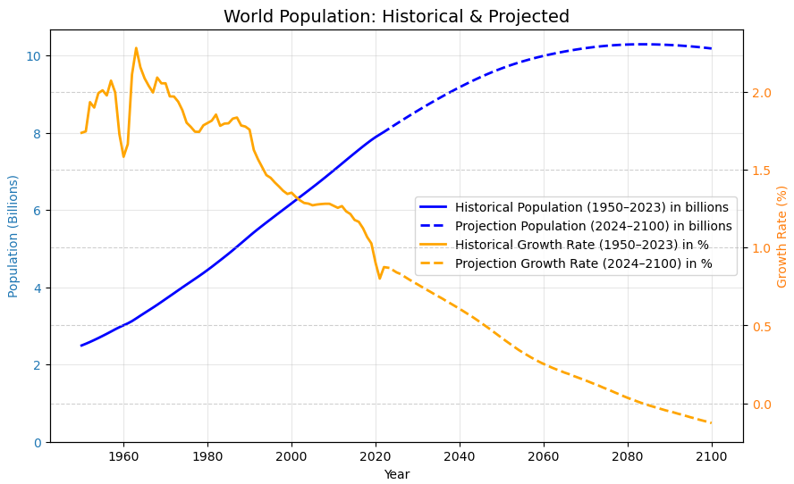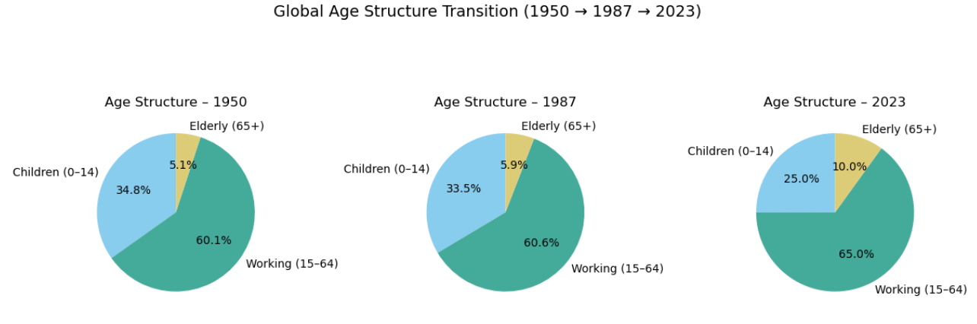
Figure 1 Figure 2
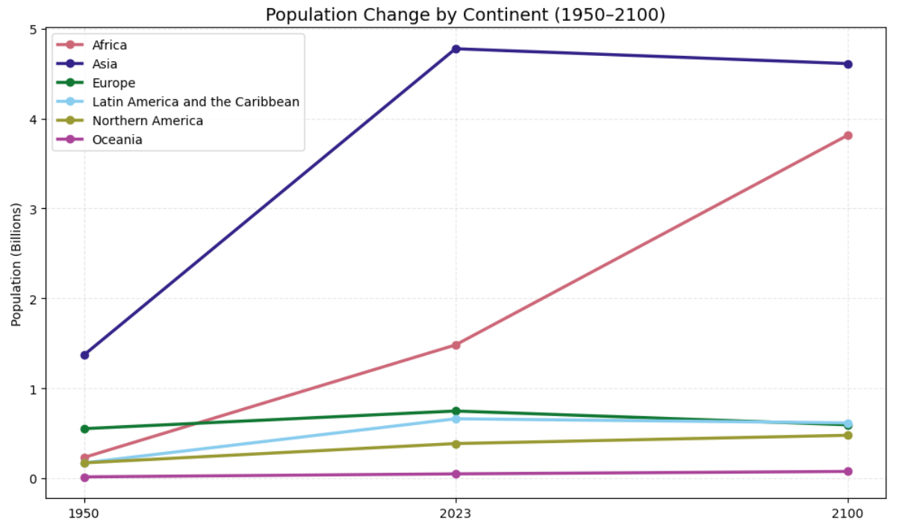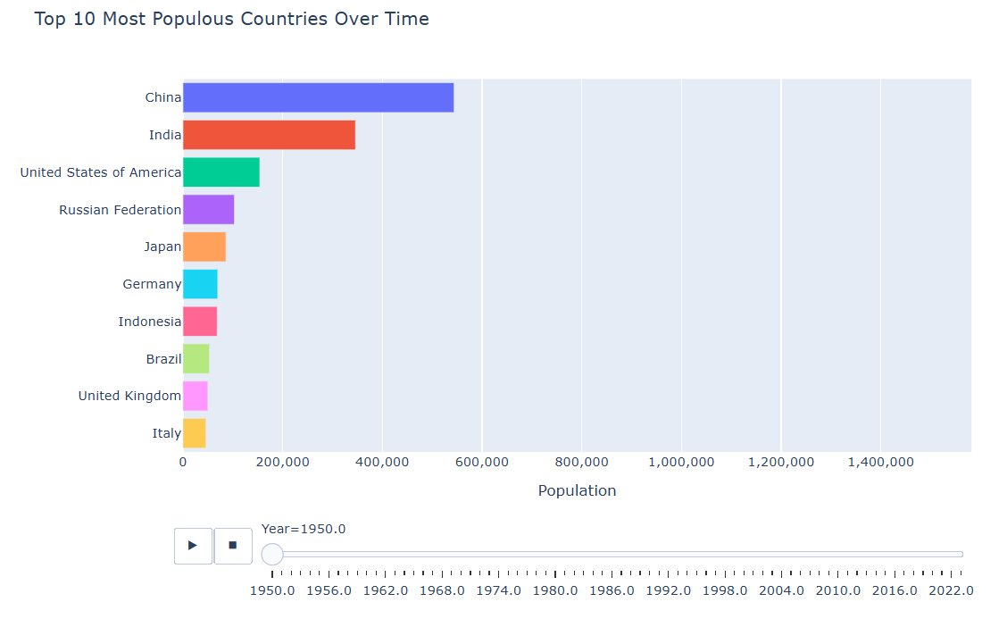
Figure 3 Figure 4
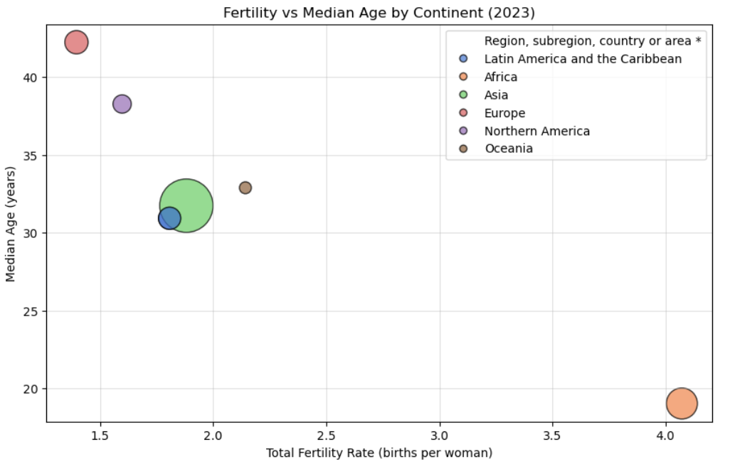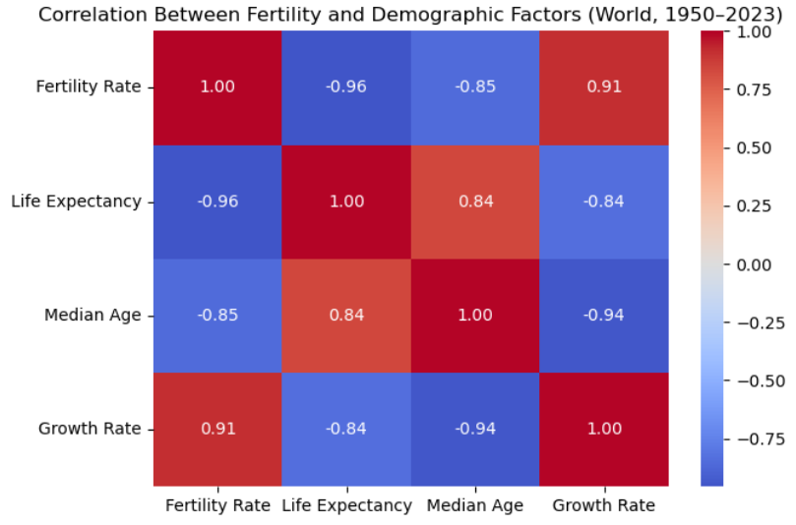
Figure 5 Figure 6
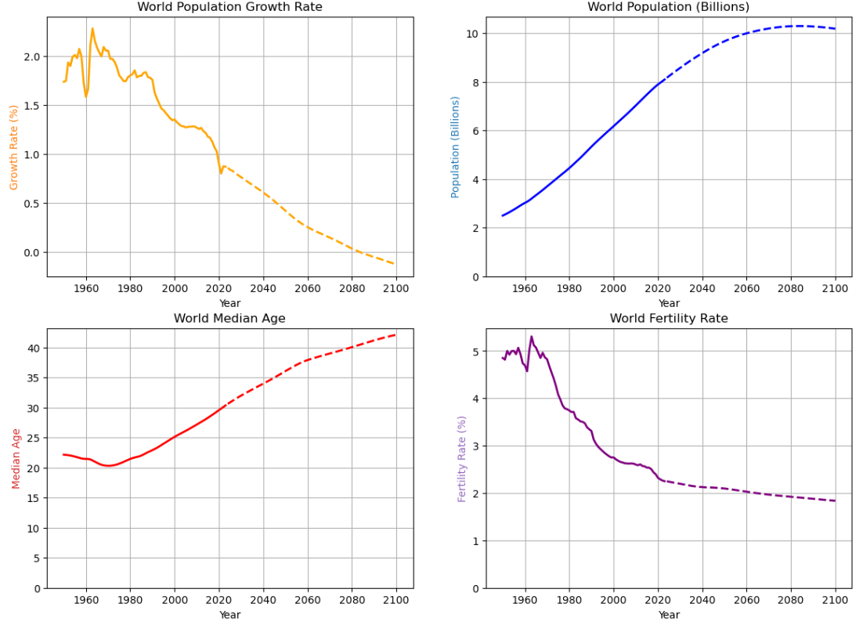
Figure 7

